### Homework 4

Name: Eduardo Wang Zheng

E-mail: eduardo@sjtu.edu.cn

1. Experiments

1.1 Performance loss of virtualization

* + 1. Performance test for disk I/O on hostOS

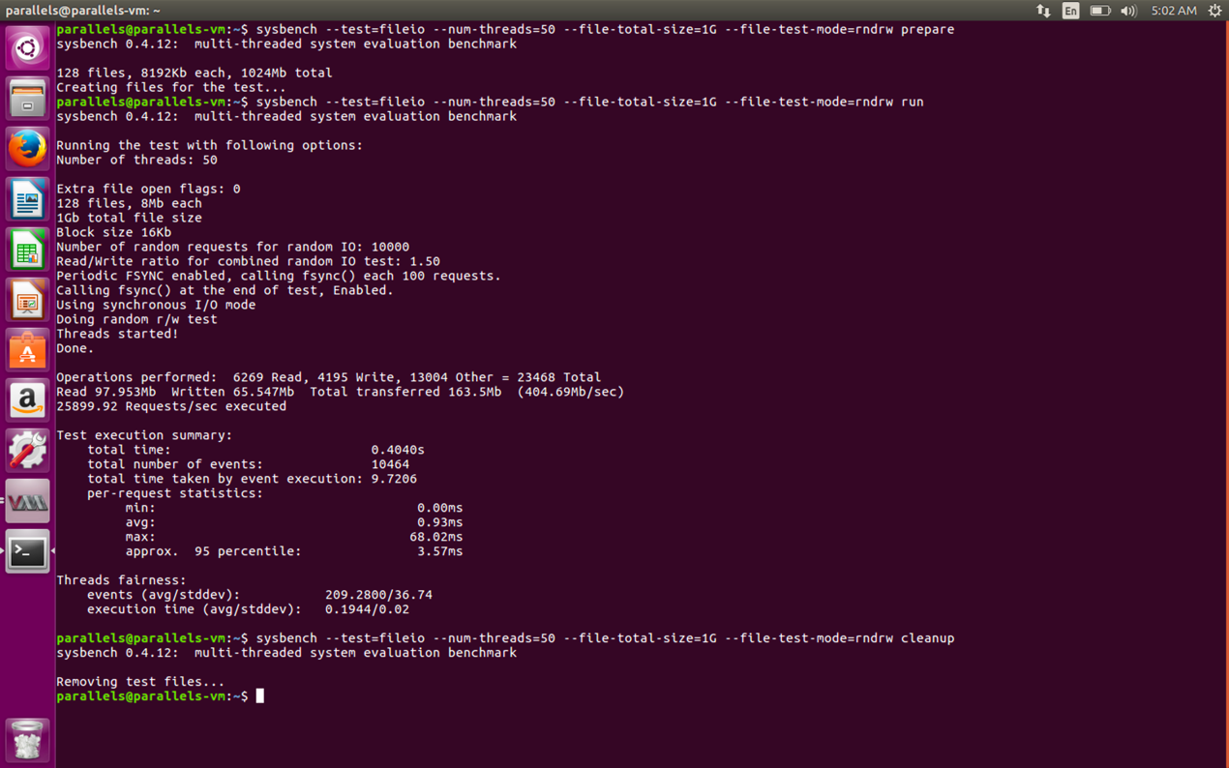

* + 1. Performance test for disk I/O on GuestOS

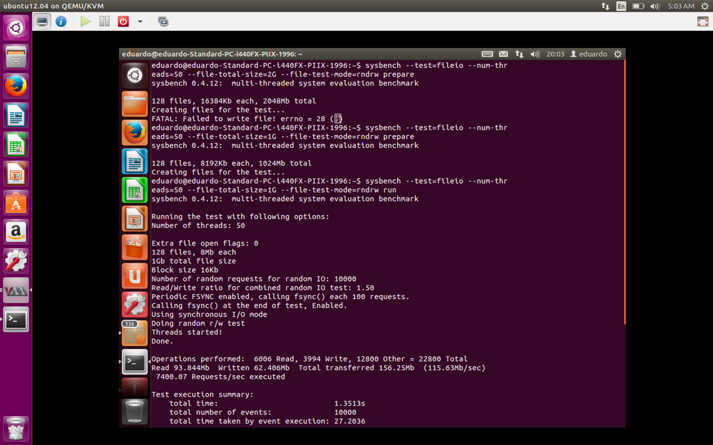

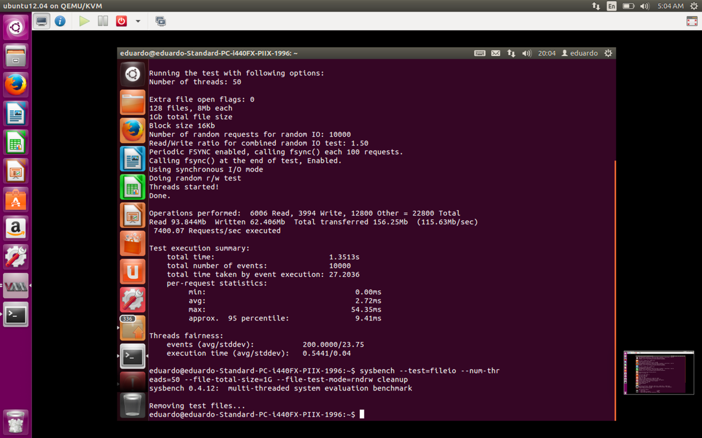

1.2 Modify the relevant code to reduce performance loss

1.2.1 Shut down GuestOS

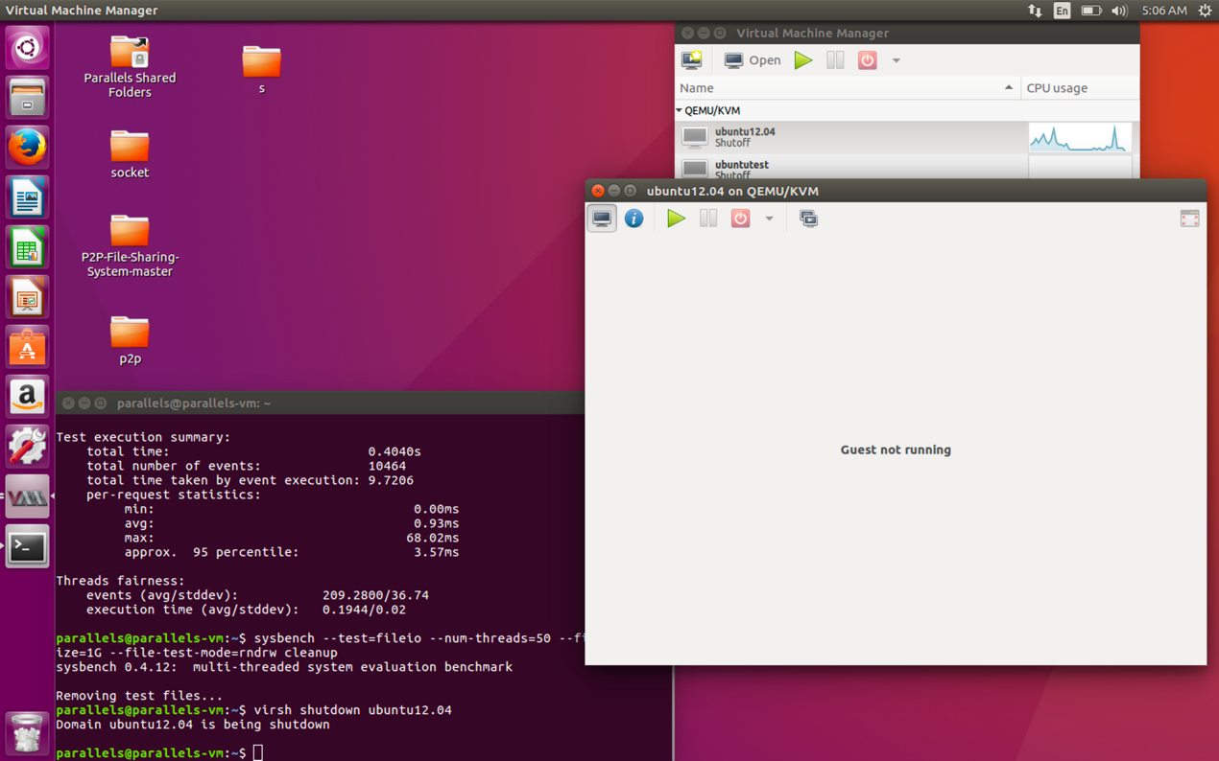

1.2.2 Modify XML configuration

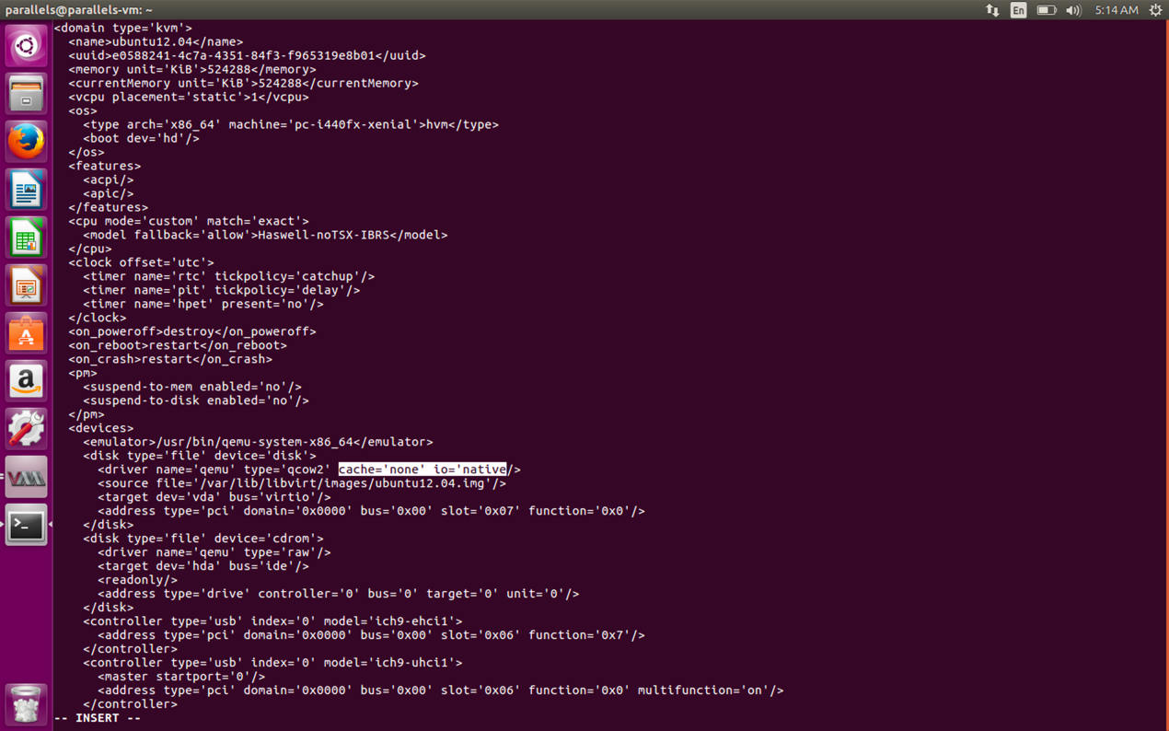



Here are some explanations of the code:

**cache='none'** means we change the cache mode selection. In this mode, the virtual machine has direct access to the host's disk cache as the following figure shows, which improves the performance.

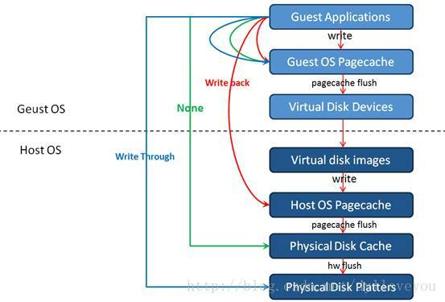

The default cache mode is **writethrough**, which is the most secure and will not cause data inconsistency, but its performance is the worst.

**io='native'** means we change the I/O mode selection.

There are two common implementations of asynchronous I/O on Linux system, one is kernel native AIO, the other is threaded AIO.

Kernel native AIO is the original asynchronous I/O implementation of kernel.

Threaded AIO is an implementation of asynchronous I/O in Linux user space. In fact, it is not a real asynchronous I/O. It simulates asynchronous IO by starting a certain number of blocking I/O threads. This implementation has many disadvantages. After all, it has a lot of thread overhead and is still under improvement.

Therefore, it is better for us to choose AIO in KVM, which improves the performance.

1.2.3 Performance test for disk I/O on GuestOS

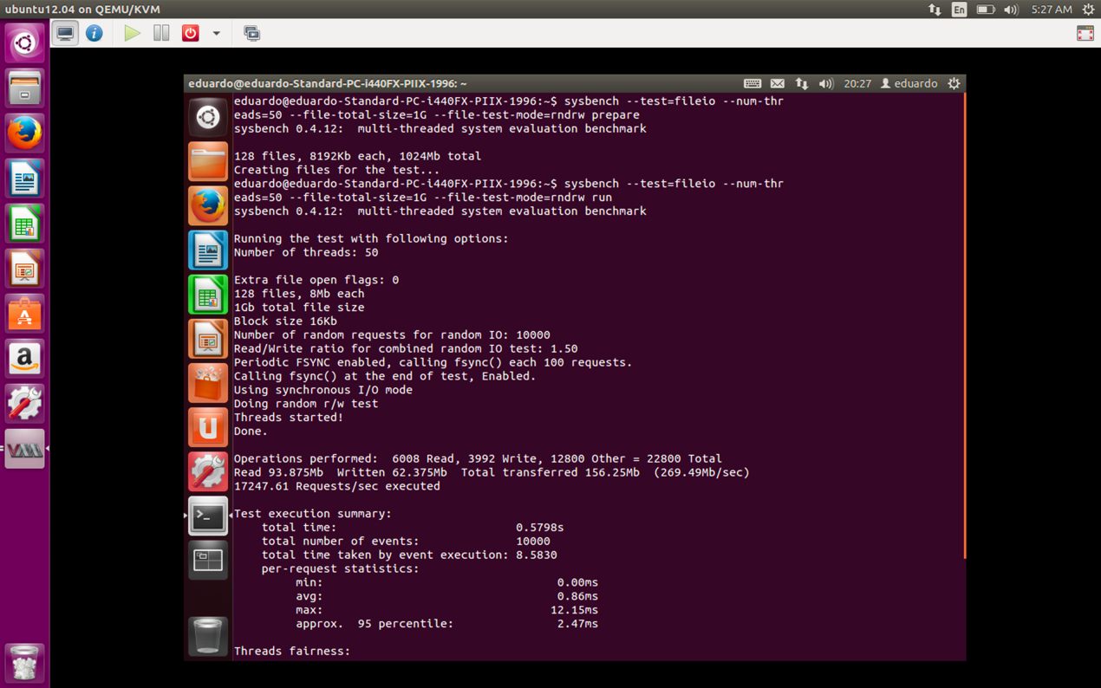

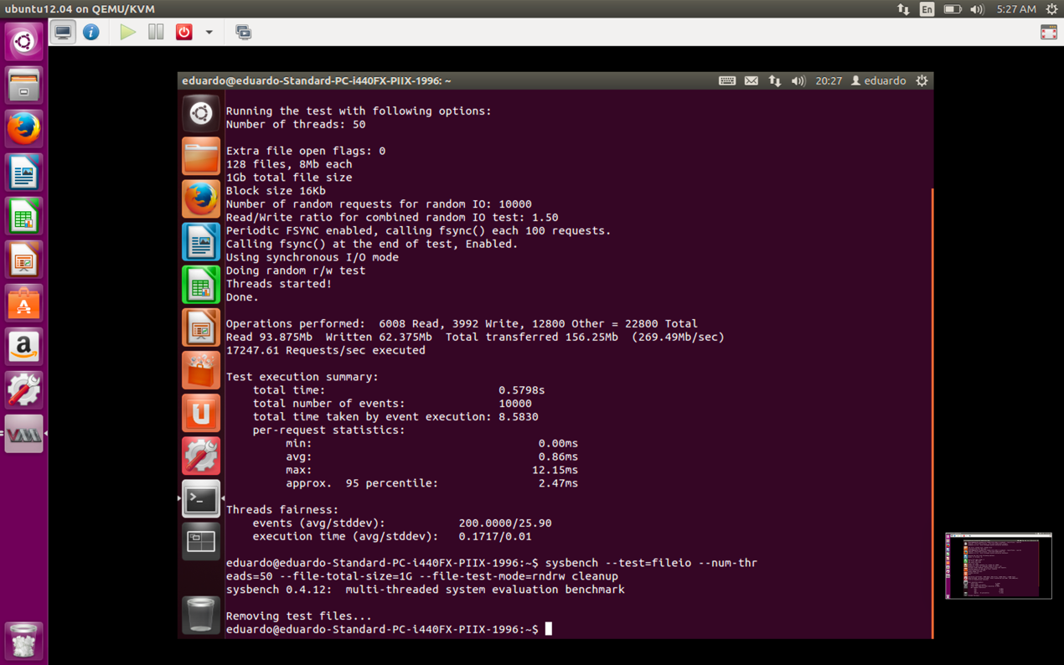

We can find that the new total execution time is 0.5798 s, which is less than the original total execution time (1.3513 s) but still more than the total execution time on hostOS (0.4040 s).